Robert Dennis

Linux administrator

9/12/19

**Need to setup a server? Follow these steps!**

1. Go to website: <https://www.centos.org/download>
2. Click on DVD ISO to get the list of downloads

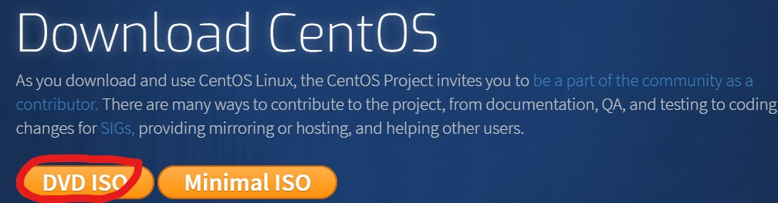

3.select this link to start your download

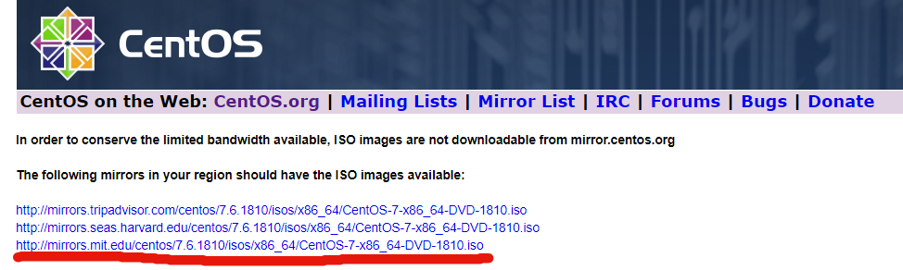

4. Open VMware or virtual box:

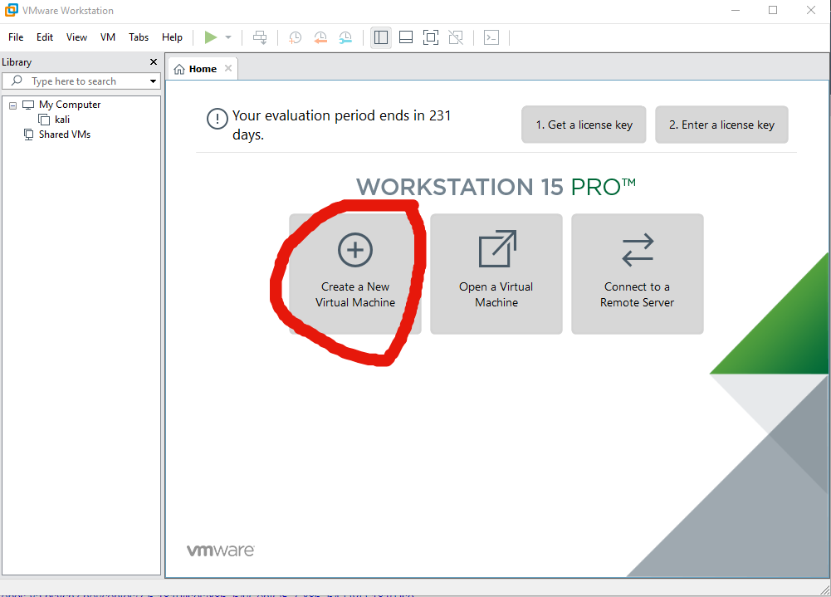

6. 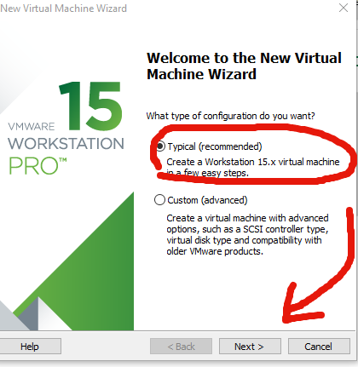

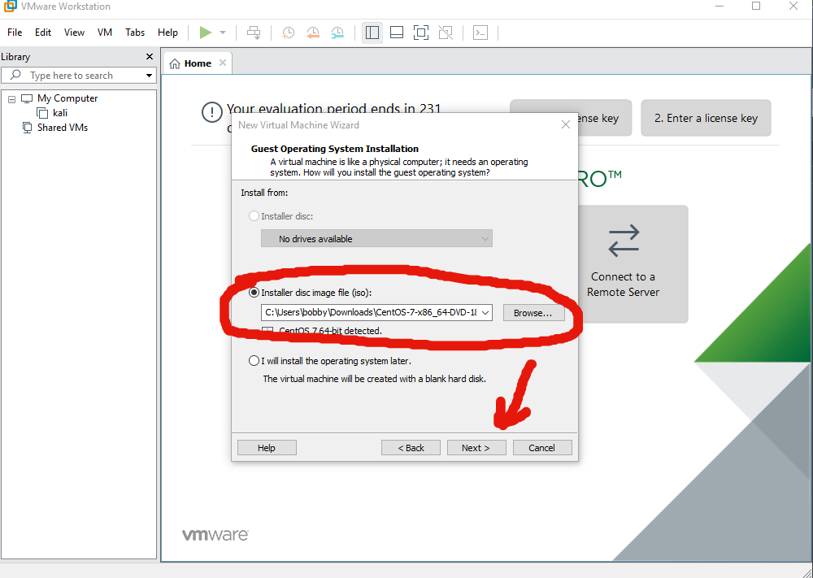

7. Name your virtual machine: I will name mine “CentOS“. Then click “next”

8. Next allot how much disk space you would like to have for your server, we will be using the default of 20gb

9. Click finish.

THE FOLLOWING STEPS ARE FOR SETTING UP CENT OS 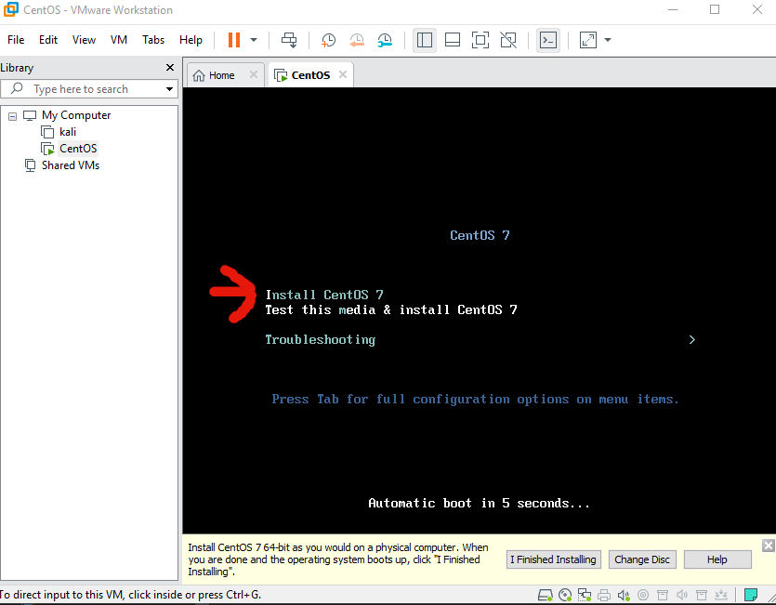

10.Click the designated language of your choice. Today we will use English.

11. next we need to verify the installation destination: 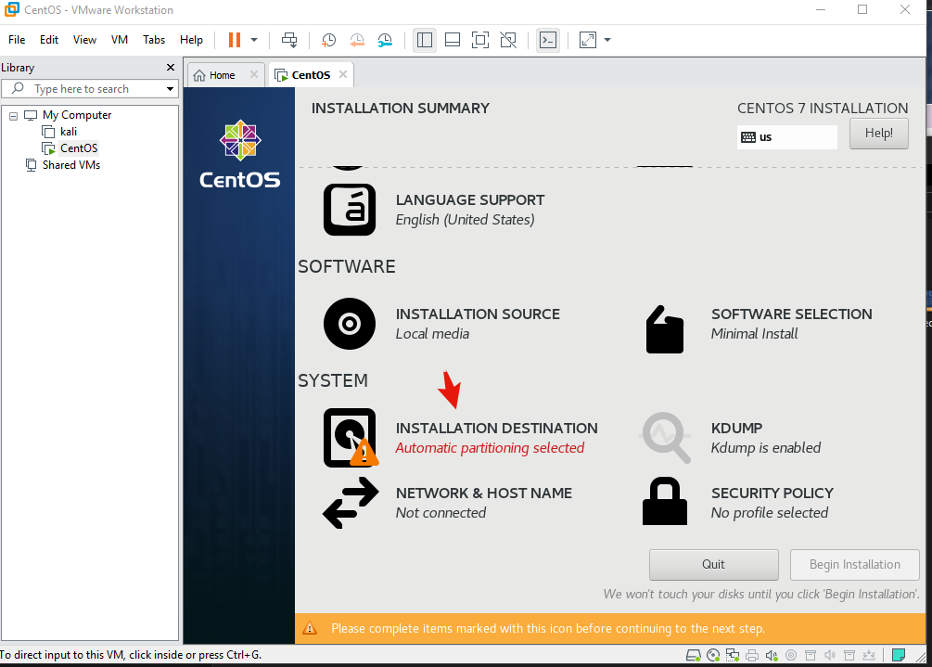

12.click on 20gb and then select done.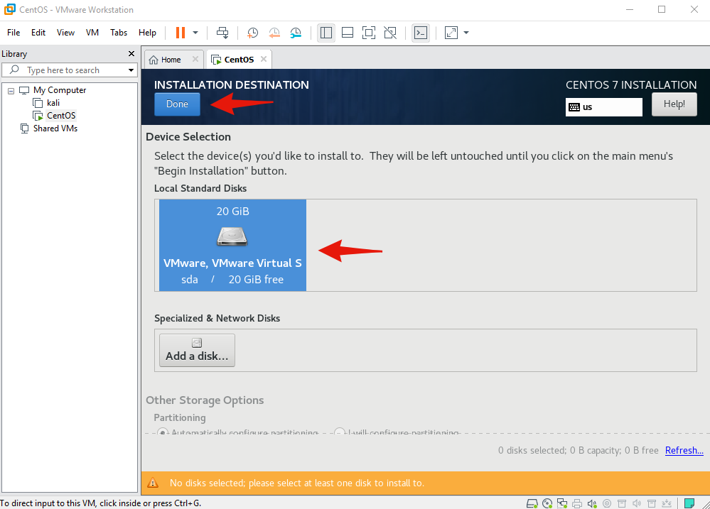

13.Begin your installation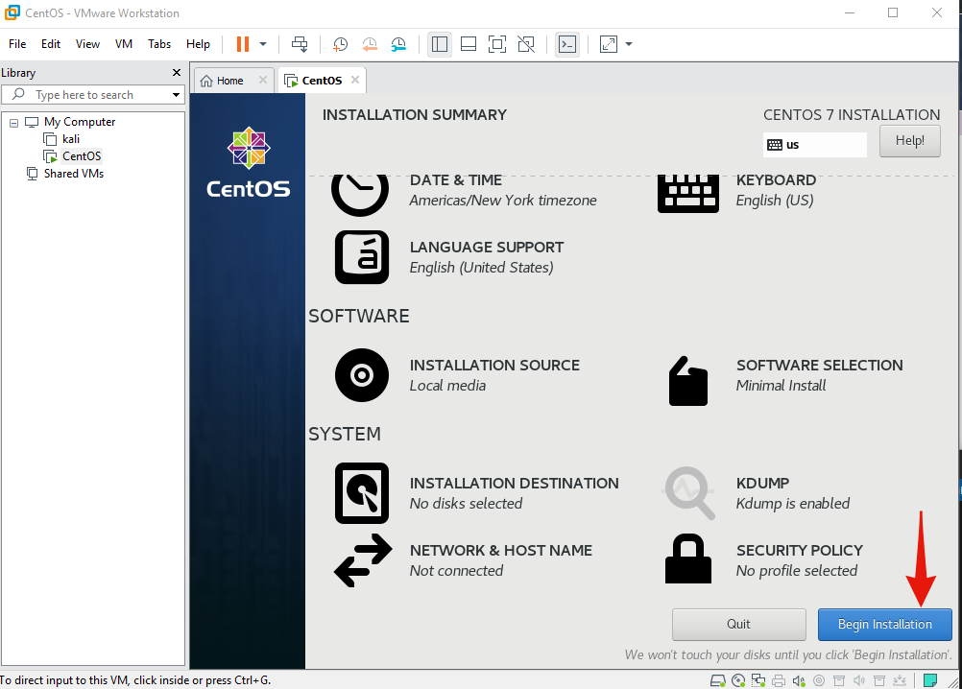

14.Create a root password and user creation by simply clicking on each one and selecting Done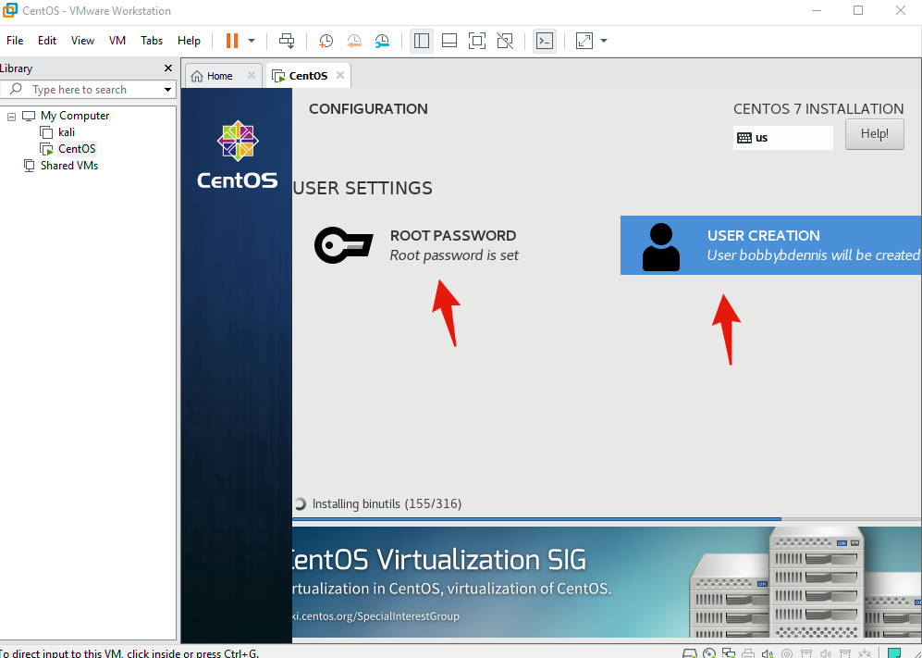

15.IMPORTANT STEP: ONCE YOU CLICK MAKE ACCOUNT CHECK OFF THIS BOX.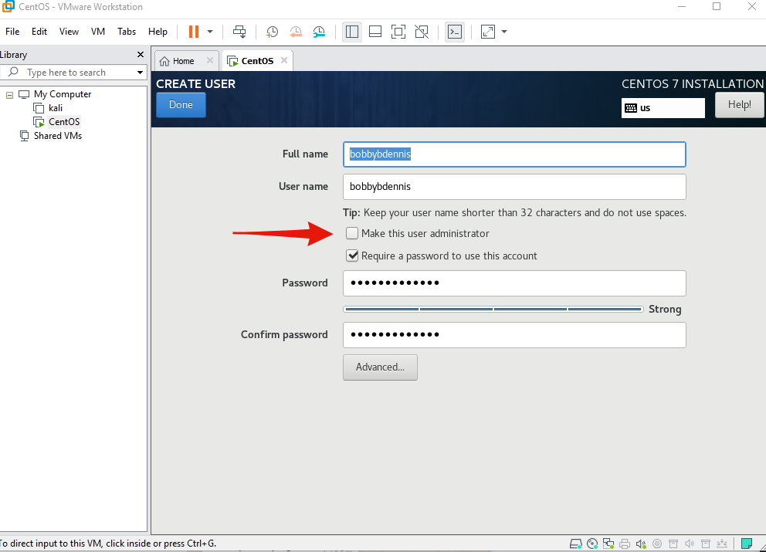

16. Press Reboot to start your server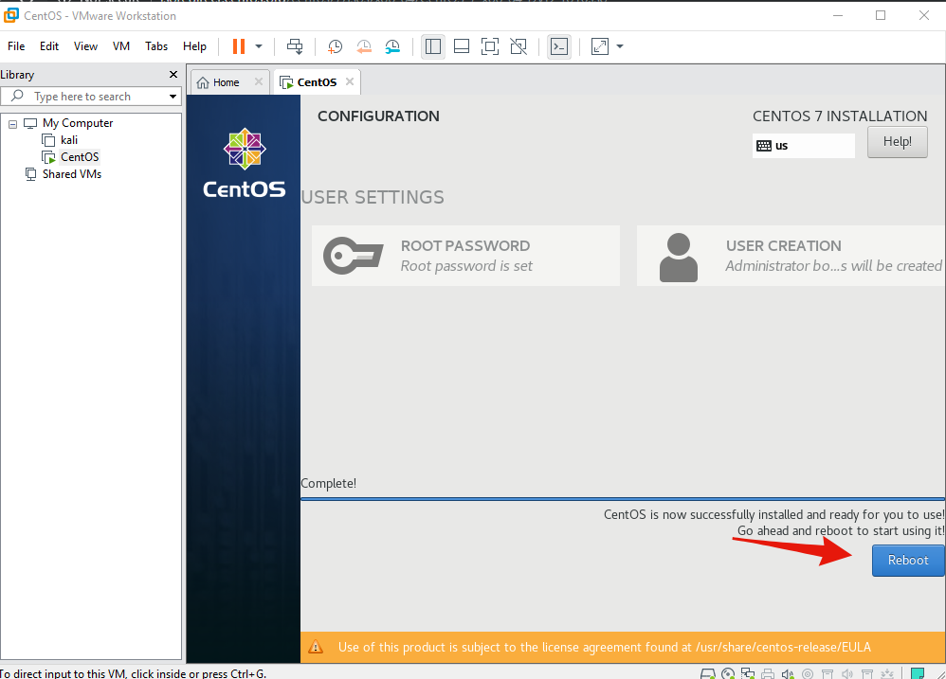

17.Log into your server with the user you have set up.

<https://gyazo.com/f393e1567572ed58109cb0fc0afde4d2>

18. Congratulations you now have the beginning of your Minecraft server! Go grief people now!